**Learning Outcomes**

1. Understanding Spinner, Image View, Dialogs
2. Understanding Seek bar

**Design a layout as shown below**

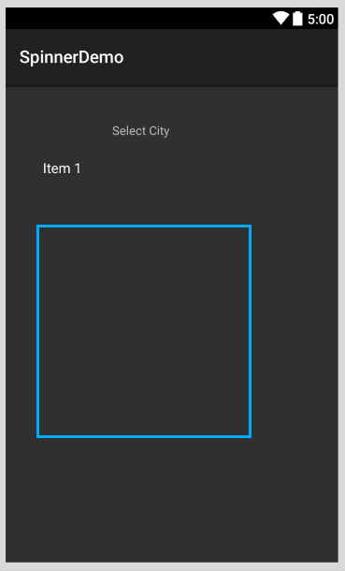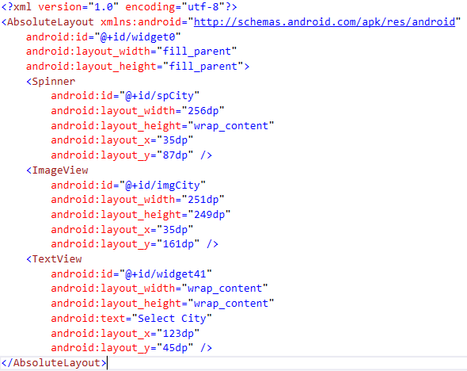

Add a spinner and an Imageview

Under values create a file called Strings.xml



Declare an array as shown in String.xml

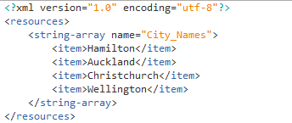

Add pictures of cities in the drawable folder (** Do not have – (dash) or _ (underscore) in the filenames for pictures)

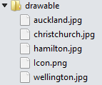

**Code**

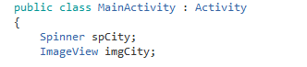

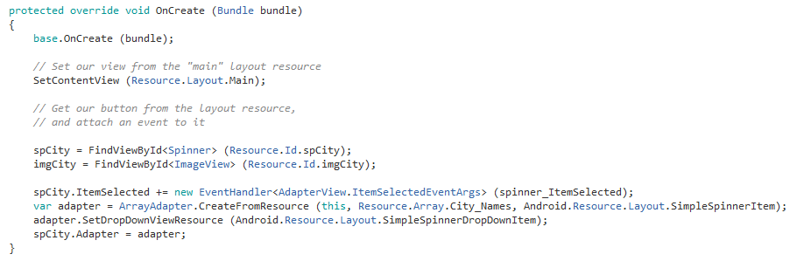

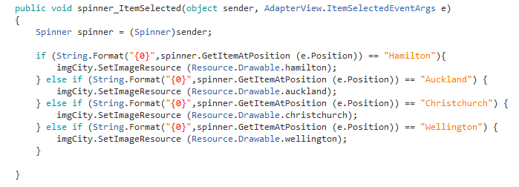

**Alert Dialogs**

Single Button, Two button or Three Button alert dialogs

This is a type of dialog, where content is displayed with a dialog title and a button. The following layout is for the example of displaying alert dialogs. We have three buttons.

 

Write the following code









**Seekbar**

SeekBar is another input type control. It takes user’s input to change the SeekBar value. Normally in windows we use Slider control for this.

**Design a layout as shown below**

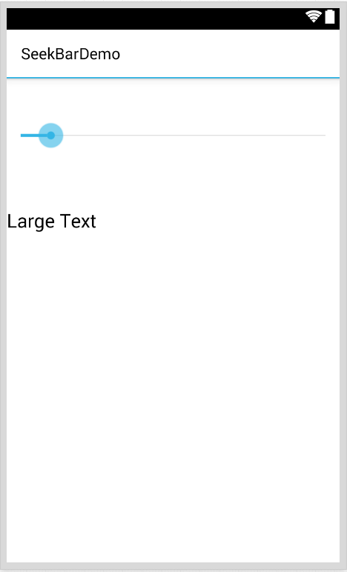

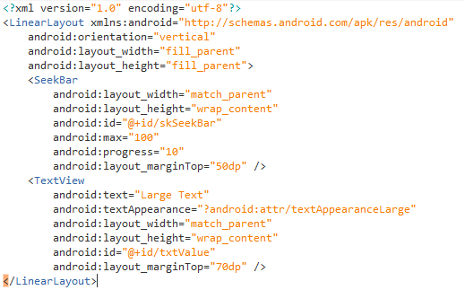

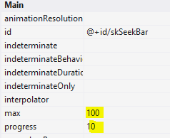

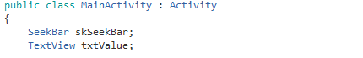

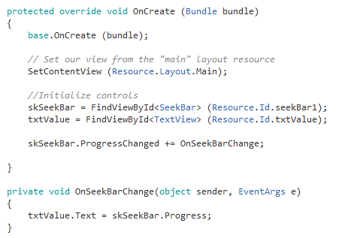

**Exercise**

1. The Music Player App

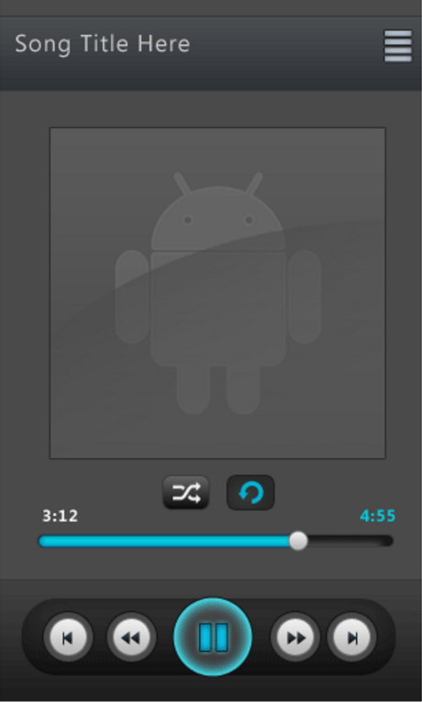

Refer to the link below for the Java version of the app

<http://www.androidhive.info/2012/03/android-building-audio-player-tutorial/>

**Functionality**

1. Searches songs on your phone
2. Lists songs
3. **Play the selected song**

Let us concentrate only on the third part of the app, by playing a song from the resources folder

In the student drive you will find the base code (all layouts) for the music player app (so you can start coding)

* To play a song from resource folder

Refer to

<https://developer.xamarin.com/recipes/android/media/audio/play_audio/>

* To find out song duration you will need to convert song duration in milliseconds to minutes: sec

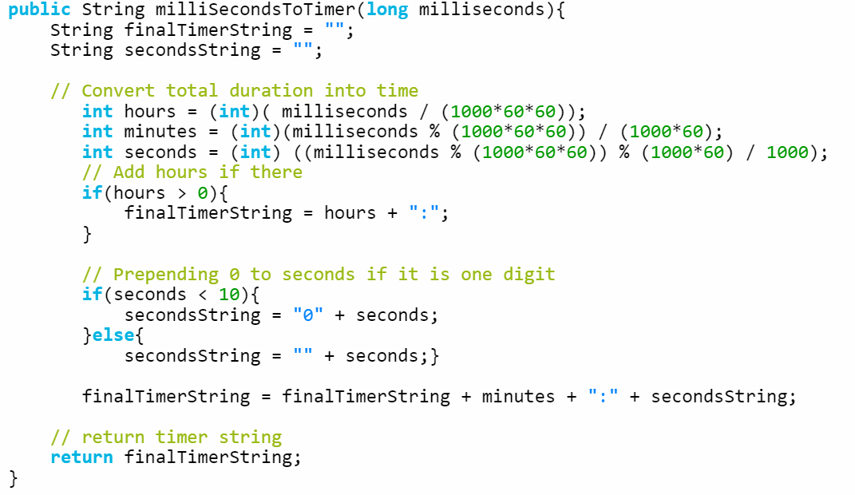

Convert the above java code to C#

1. To change the progress bar status as the song is playing.